

School of Computer Science, UPES,
Dehradun

August– December- 2026

Bubble Sort -
Submitted to: Sir Sandeep Kumain,
PROFFESOR UPES

Submitted by: RUDRAKSH CHIKARA
SAP ID: 590025989
Semester:3rd
Batch: 66
Course: Design and Analysis of Algorithm
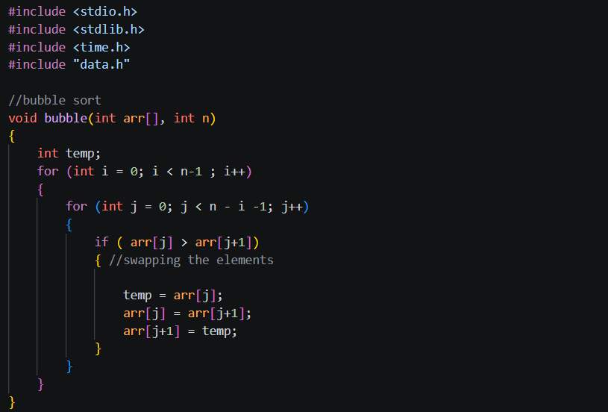

Selection Sort –
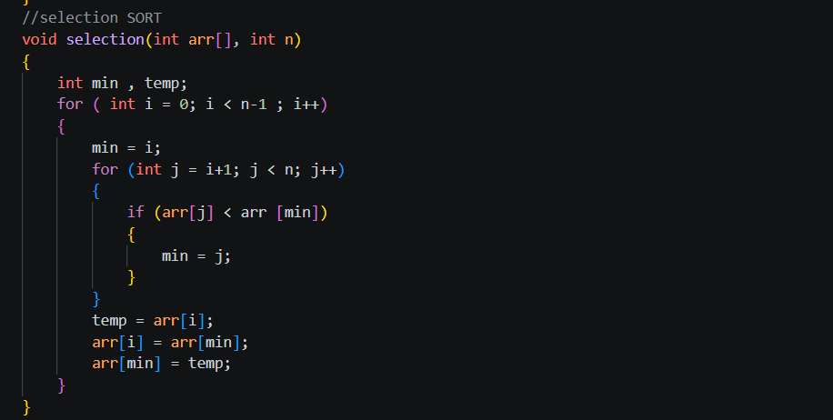

Insertion Sort –

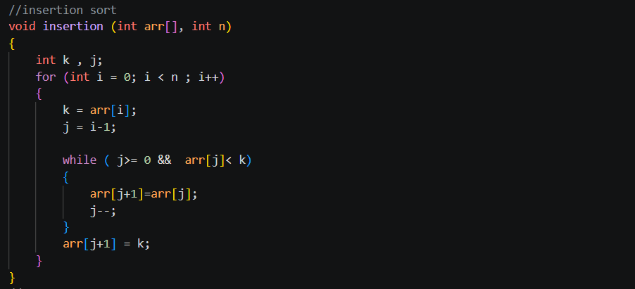

Merge Sort –
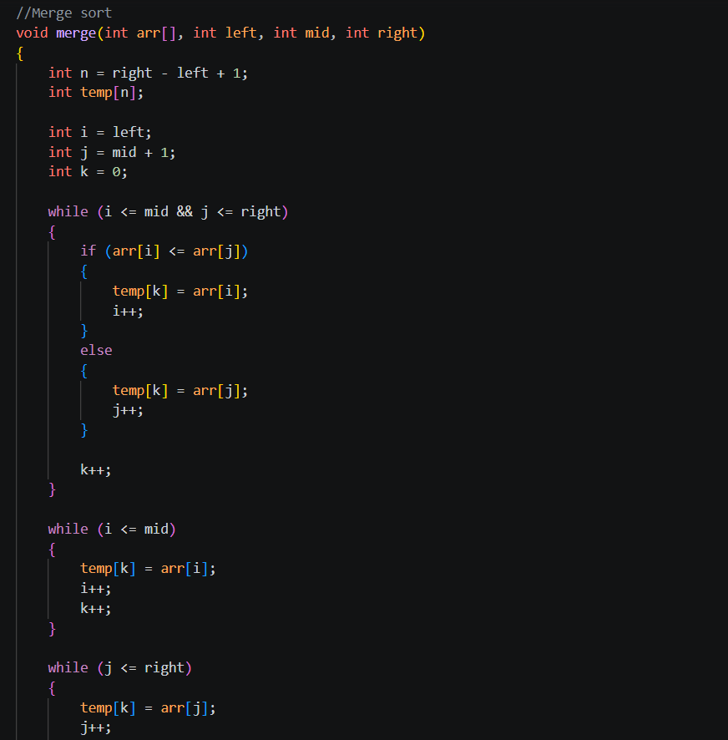

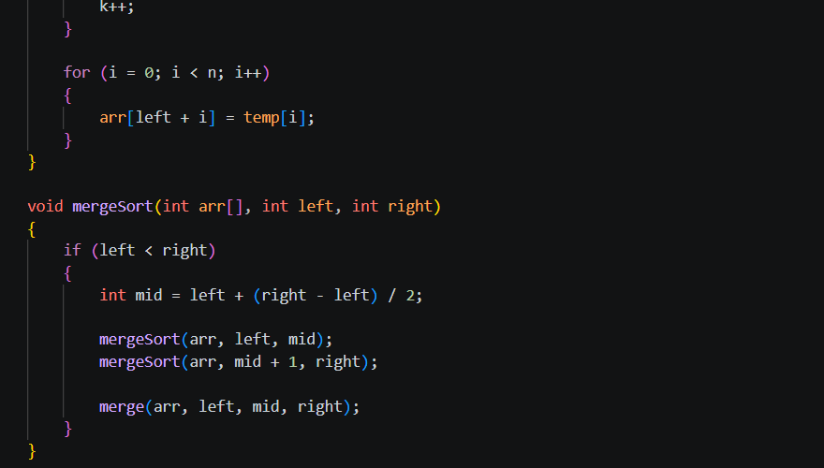

Quick Sort –
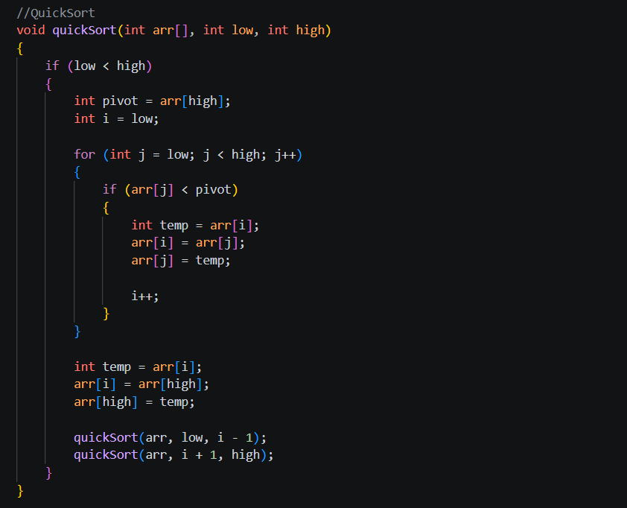

Linear Search –
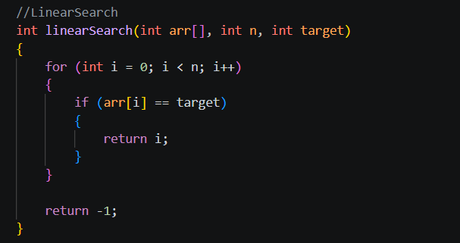

Binary Search –
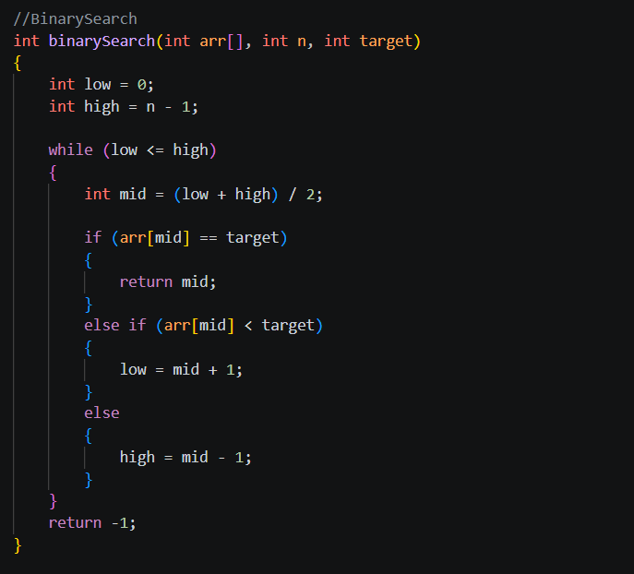
Python code of graph for finding time complexity –
